[1.36392405 1.38924051 1.37974684 1.28797468 1.2056962 1.30696203

1.28164557 1.25949367 1.22468354 1.25316456 1.31329114 1.25949367

1.2056962 1.36708861 1.40822785 1.39873418 1.30063291 1.42405063

1.44303797 1.46518987 1.48417722 1.49683544 1.40506329 1.47468354

1.74367089 1.61392405 1.65506329 1.52531646 1.57278481 1.59493671

1.53481013 1.70886076 1.59177215 1.61392405 1.54113924 1.59493671

1.60126582 1.42088608 1.64556962 1.63924051 1.5443038 1.58544304

1.45886076 1.57911392 1.52531646 1.4778481 1.45253165 1.38291139

1.31329114 1.49367089]

[-124.09268821 -125.45585834 -119.96689848 -110.58561791 -113.3677513

-129.36548089 -126.60453351 -128.69961693 -102.63322873 -107.99285536

-114.08937277 -94.45884766 -102.55506728 -121.52978482 -139.6440631

-151.91357844 -105.34863659 -148.45127423 -142.25197861 -121.33533417

-139.53712963 -130.81703187 -113.74514702 -145.37198886 -177.95377576

-140.34029967 -152.05685809 -155.60012272 -140.03747372 -149.78206974

-129.58511796 -152.97582971 -138.9095093 -135.56079569 -140.19612877

-138.7116421 -145.42682677 -130.0979891 -147.78743811 -165.40501645

-158.12122621 -138.99906409 -120.54847307 -157.02571508 -141.49046082

-130.54525057 -136.10773347 -127.33228663 -127.13801838 -143.5678703 ]

[1.28888889 1.32222222 1.33333333 1.33333333 1.56666667 2.19444444

2.28333333 2.43888889 2.51111111 2.67222222 2.78333333 2.83333333

2.55 1.60555556 1.61111111 1.58888889 1.58888889 1.83888889

1.95555556 1.93333333 1.97222222 2.05 2.01111111 1.97222222

1.80555556 1.91666667 1.75555556 1.96111111 1.96111111 2.05

2.06111111 2.27777778 2.28888889 2.57777778 2.51111111 2.57777778

2.51111111 2.51111111 2.57777778 2.51111111 2.51111111 2.51111111

2.57777778 2.57777778 2.57777778 2.51111111 2.51111111 2.51111111

2.51111111 2.57777778]

[ -70.46745731 -70.64709545 -70.46403479 -70.48625702 -76.35093152

-130.56004138 -117.50589309 -124.22842589 -142.93462522 -157.88049071

-167.00728689 -168.17942988 -157.37773296 -79.574673 -79.68174112

-79.90562237 -79.91673348 -92.03115047 -95.15217939 -92.51423745

-99.19911038 -105.04186796 -99.7037653 -93.67336746 -87.52710199

-96.70986315 -83.01049888 -97.10197443 -97.10197443 -102.05563997

-102.05778257 -131.48331405 -134.99162423 -151.57343775 -144.78655132

-151.57343775 -144.77544021 -144.77544021 -151.57343775 -144.77544021

-144.77544021 -144.78655132 -151.58454886 -151.58454886 -151.58454886

-144.78655132 -144.78655132 -144.78655132 -144.78655132 -151.58454886]

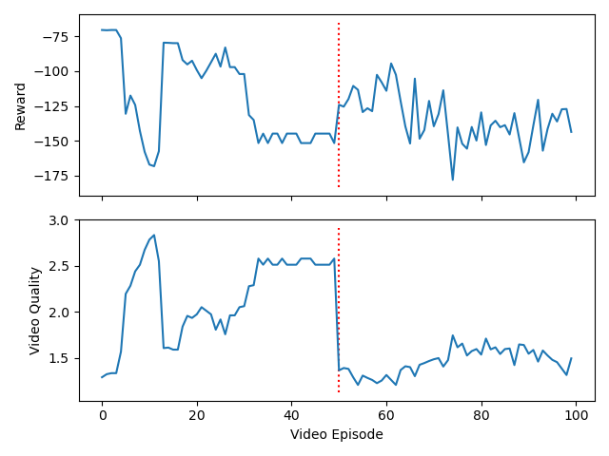

[1.3164557 1.35443038 1.32911392 1.21518987 1.14240506 1.32594937

1.2721519 1.25 1.29113924 1.25316456 1.3164557 1.50632911

1.52848101 1.38924051 1.48734177 1.44303797 1.44936709 1.46835443

1.4778481 1.5 1.56962025 1.48417722 1.4335443 1.62974684

1.52848101 1.52531646 1.4556962 1.57594937 1.5 1.56962025

1.50949367 1.46835443 1.63291139 1.57278481 1.50949367 1.5443038

1.68037975 1.44936709 1.55379747 1.60126582 1.65822785 1.58544304

1.60759494 1.57278481 1.59810127 1.5443038 1.74367089 1.69620253

1.6835443 1.76265823]

[-121.45313459 -127.33702901 -112.50384946 -112.35107589 -114.80714301

-120.97569223 -118.25424856 -109.68396369 -125.71547493 -100.21193374

-119.60580779 -152.93910528 -170.56355315 -109.29395455 -138.62331765

-136.22611641 -128.91391305 -149.56767079 -153.67375367 -149.9011731

-165.89081573 -143.81836643 -142.99503994 -170.18592678 -140.94220232

-164.51701985 -150.82045106 -131.79768112 -145.21530947 -151.1175199

-144.69182374 -137.38938826 -159.93746711 -128.19228212 -132.1633142

-143.94366951 -145.26396706 -140.45745001 -141.05309 -153.45123234

-155.16353959 -154.11954744 -160.70834035 -161.63007147 -160.08392417

-158.88149513 -170.78460611 -167.80158919 -162.91815895 -161.71133908]

[1.67777778 1.88333333 2.05 2.22777778 2.52222222 2.67222222

2.72777778 2.73888889 2.76111111 2.79444444 2.87222222 2.90555556

2.91111111 2.91111111 2.91111111 2.91111111 2.91111111 2.91111111

2.91111111 2.91111111 2.91111111 2.91111111 2.91111111 2.91111111

2.91111111 2.91111111 2.91111111 2.91111111 2.91111111 2.91111111

2.91111111 2.91111111 2.91111111 2.91111111 2.91111111 2.91111111

2.91111111 2.91111111 2.91111111 2.91111111 2.91111111 2.91111111

2.91111111 2.91111111 2.91111111 2.91111111 2.91111111 2.91111111

2.91111111 2.91111111]

[ -95.84009368 -98.72515102 -105.34178904 -129.93972115 -141.94304714

-153.56787615 -155.06130498 -154.83858474 -155.12717172 -157.04092667

-163.61564963 -168.55201969 -169.06864775 -169.07975887 -169.07975887

[ -95.84009368 -98.72515102 -105.34178904 -129.93972115 -141.94304714

-153.56787615 -155.06130498 -154.83858474 -155.12717172 -157.04092667

-163.61564963 -168.55201969 -169.06864775 -169.07975887 -169.07975887

-169.06864775 -169.05753664 -169.06864775 -169.07975887 -169.07975887

-169.06864775 -169.05753664 -169.07975887 -169.06864775 -169.06864775

-169.07975887 -169.06864775 -169.06864775 -169.06864775 -169.05753664

-169.07975887 -169.05753664 -169.06864775 -169.07975887 -169.06864775

-169.05753664 -169.06864775 -169.06864775 -169.05753664 -169.06864775

-169.07975887 -169.06864775 -169.05753664 -169.06864775 -169.05753664

-169.07975887 -169.07975887 -169.06864775 -169.06864775 -169.05753664]

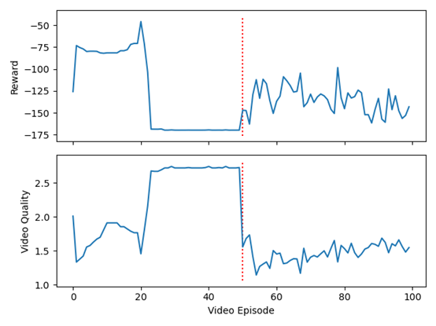

[1.4778481 1.26898734 1.2721519 1.20886076 1.3164557 1.1835443

1.32594937 1.37974684 1.55696203 1.37341772 1.27531646 1.47151899

1.5664557 1.31012658 1.3164557 1.47468354 1.4556962 1.5443038

1.46202532 1.48101266 1.50316456 1.52848101 1.46835443 1.58544304

1.54113924 1.46835443 1.5 1.47151899 1.4778481 1.55379747

1.46202532 1.5 1.39240506 1.41455696 1.47151899 1.46835443

1.62658228 1.43987342 1.56012658 1.51582278 1.51582278 1.48417722

1.53164557 1.56012658 1.62341772 1.72151899 1.47468354 1.55379747

1.61392405 1.60443038]

[-136.5333082 -141.27019253 -147.350086 -121.68714582 -139.0477654

-118.02662078 -128.89662917 -155.32253816 -152.4227789 -130.0998013

-116.96481376 -148.65171634 -141.7769282 -109.28363159 -118.16685005

-143.64468311 -146.9218162 -135.28411632 -146.40249175 -140.03820423

-156.52629456 -152.76293679 -142.97349805 -133.95046236 -128.60745063

-137.16933668 -157.01911085 -113.47901731 -139.99854919 -122.62514076

-128.2973611 -141.12425893 -125.04384702 -115.64411278 -128.6804756

-120.96927201 -148.27593092 -129.47580711 -150.34965048 -137.34728411

-160.56785976 -149.60587438 -144.73210644 -172.50131348 -156.1261553

-154.49057761 -127.31860957 -145.33067489 -178.78003728 -158.32100216]

[1.6 1.6 1.63333333 1.63333333 1.5 1.5

1.5 1.5 1.66666667 1.66666667 1.66666667 1.66666667

1.66666667 1.66666667 1.66666667 1.66666667 1.66666667 1.68333333

1.68333333 2.08333333 2.1 2.21666667 2.21666667 2.21666667

2.51666667 2.51666667 2.51666667 2.51666667 2.51666667 2.51666667

2.51666667 2.51666667 2.51666667 2.51666667 2.51666667 2.51666667

2.51666667 2.51666667 2.51666667 2.51666667 2.51666667 2.51666667

2.51666667 2.51666667 2.51666667 2.51666667 2.51666667 2.51666667

2.21666667 2.51666667]

[ -87.75829503 -87.79162836 -90.46701612 -90.47812723 -82.75721045

-82.75721045 -82.72387711 -82.73498823 -90.80266986 -90.78044764

-90.79155875 -90.81378097 -90.78044764 -90.78044764 -90.80266986

-90.79155875 -90.78044764 -93.85100319 -93.8621143 -120.58822013

-120.28103231 -130.60655092 -130.59543981 -130.59543981 -161.07276318

-161.07276318 -161.06165207 -161.03942985 -161.03942985 -161.03942985

-161.06165207 -161.05054096 -161.03942985 -161.07276318 -161.05054096

-161.03942985 -161.07276318 -161.07276318 -161.03942985 -161.05054096

-161.05054096 -161.06165207 -161.05054096 -161.06165207 -161.06165207

-161.05054096 -161.07276318 -161.03942985 -130.5843287 -161.07276318]

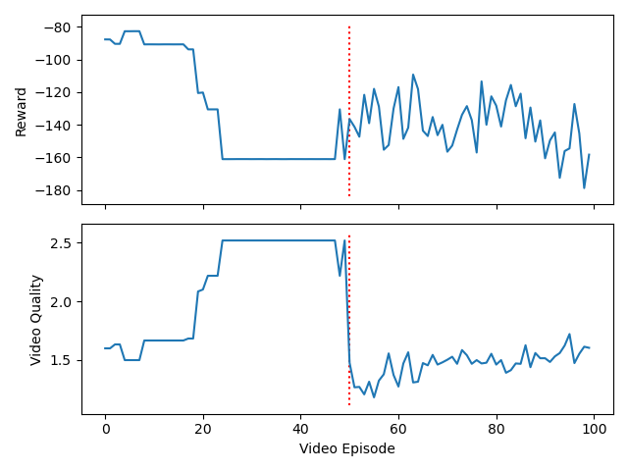

[1.48101266 1.42088608 1.39873418 1.28797468 1.4335443 1.25316456

1.23734177 1.39873418 1.26898734 1.36075949 1.4778481 1.4556962

1.30696203 1.31329114 1.46202532 1.48734177 1.46835443 1.52531646

1.54113924 1.5664557 1.56012658 1.44620253 1.56329114 1.44620253

1.45886076 1.4556962 1.64873418 1.56012658 1.57911392 1.53797468

1.57594937 1.49050633 1.54746835 1.44620253 1.46202532 1.51265823

1.56329114 1.56012658 1.59493671 1.66139241 1.73734177 1.57911392

1.5221519 1.63291139 1.73734177 1.49050633 1.5 1.65189873

1.49050633 1.61075949]

[-108.0834152 -110.09492234 -111.957454 -97.07459659 -136.66213364

-110.12229953 -114.19894952 -118.7229799 -122.97498795 -117.97871351

-134.34071929 -135.24353752 -104.86593574 -118.07616239 -126.41710803

-128.00528907 -136.60494242 -150.27887937 -155.66514272 -162.78381705

-145.49961256 -130.84959393 -137.00103067 -144.06522987 -145.91139519

-140.54886284 -171.04739021 -147.60814748 -165.15728482 -146.27773336

-151.33792059 -155.18528799 -139.72642458 -124.66542452 -150.65059274

-119.85080404 -133.88366134 -151.35967407 -166.54062093 -151.67533107

-193.89282625 -158.84870407 -137.04991362 -136.91480872 -162.96593797

-128.77519855 -133.29687138 -140.77120449 -173.82203667 -154.03166131]

[1.49444444 2.43888889 2.55 2.52222222 2.53888889 2.55

2.55 2.55 2.55 2.55 2.55 2.55

2.55 2.55 2.55 2.55 2.55 2.55

2.55 2.55 2.53888889 2.53888889 2.53888889 2.53888889

2.53888889 2.53888889 2.53888889 2.53888889 2.54444444 2.54444444

2.54444444 2.54444444 2.53333333 2.53333333 2.52777778 2.52777778

2.52777778 2.45 2.45 2.45 2.45 2.52222222

2.51666667 2.51666667 2.42777778 2.42777778 2.48333333 2.48333333

2.48333333 2.47777778]

[ -76.97971085 -151.43186576 -154.57804746 -147.46780553 -145.89817323

-145.68823761 -145.68823761 -145.69934872 -145.99325375 -145.68823761

-145.69934872 -145.68823761 -145.68823761 -145.99325375 -145.99325375

-145.69934872 -145.99325375 -145.99325375 -145.68823761 -145.69934872

-143.27823064 -143.58324678 -143.27823064 -143.58324678 -143.27823064

-143.28934175 -143.27823064 -143.27823064 -145.5012399 -145.5012399

-145.80625603 -145.80625603 -145.54577595 -145.53466484 -145.53639984

-145.54751095 -145.53639984 -144.21885222 -144.21885222 -144.21885222

-144.51275724 -145.62039455 -145.05716896 -145.36218509 -136.55250437

-136.55250437 -144.21219439 -144.21219439 -143.45079674 -143.12554879]

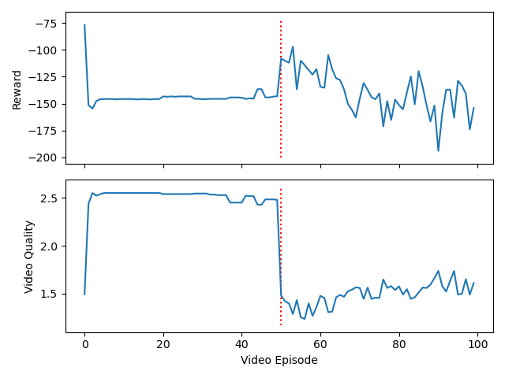

Target

[1.75949367 1.73734177 1.91139241 1.23734177 1.19303797 1.20253165

1.30063291 1.25316456 1.26898734 1.39240506 1.44620253 1.45886076

1.56329114 1.59177215 1.47468354 1.41455696 1.40506329 1.26898734

1.38291139 1.4335443 1.37974684 1.46202532 1.41772152 1.2721519

1.45253165 1.26898734 1.34493671 1.40189873 1.41139241 1.5443038

1.32911392 1.35126582 1.48417722 1.55063291 1.23734177 1.57911392

1.46202532 1.37341772 1.37341772 1.57278481 1.5 1.4556962

1.51582278 1.50316456 1.35126582 1.4556962 1.39556962 1.53797468

1.50949367 1.41455696]

[-167.92029275 -189.10052795 -179.09395563 -110.2074345 -105.99092172

-117.97612691 -107.59153248 -114.68190411 -122.88703673 -135.5084149

-146.4438365 -127.32840903 -146.07983626 -153.90554907 -142.85234394

-138.81551519 -139.39152882 -113.73155442 -111.95058615 -129.85205225

-125.93702811 -141.69355579 -135.95377662 -117.07891239 -130.75054222

-102.88109346 -138.63955 -140.12987019 -125.82958067 -151.2714811

-131.45470891 -145.43495232 -137.17703672 -134.39963862 -128.50413497

-144.46028377 -134.98792582 -126.53819658 -130.69800083 -153.22729365

-147.96111323 -138.31372441 -129.55920193 -137.09553455 -120.06077637

-125.62420038 -123.38882445 -137.89658115 -162.82271883 -148.81653491]

[1.05 1.05 1.05 1.08333333 1.1 1.1

1.1 1.11666667 1.11666667 1.13333333 1.5 1.71666667

1.78333333 1.95 2.16666667 2.18333333 2.31666667 2.38333333

2.38333333 2.38333333 2.41666667 2.3 1.4 1.25

1.25 1.25 1.25 1.25 1.25 1.25

1.25 1.25 1.25 1.28333333 1.28333333 1.28333333

1.28333333 1.28333333 1.28333333 1.28333333 1.36666667 1.36666667

1.36666667 1.38333333 1.38333333 1.76666667 1.63333333 1.81666667

1.95 2.11666667]

[ -65.01735741 -65.01735741 -65.01735741 -65.71574505 -65.74171433

-65.73060322 -65.71949211 -65.49300262 -65.49300262 -65.89204429

-102.35823261 -109.60419032 -110.62040956 -112.78469507 -126.05703829

-126.4824933 -151.98480984 -159.635017 -159.82685971 -159.50732898

-160.58933881 -155.20270675 -79.56938561 -68.69392217 -68.69392217

-68.68281106 -68.66058884 -68.68281106 -68.67169995 -68.66058884

-68.66058884 -68.69392217 -68.69392217 -74.26528704 -74.26528704

-74.24306482 -74.27639816 -74.26528704 -74.26528704 -74.27639816

-76.57468184 -76.57468184 -76.57468184 -76.9737235 -76.96261239

-113.78295142 -102.91704493 -116.90553561 -132.31745012 -142.7954184 ]

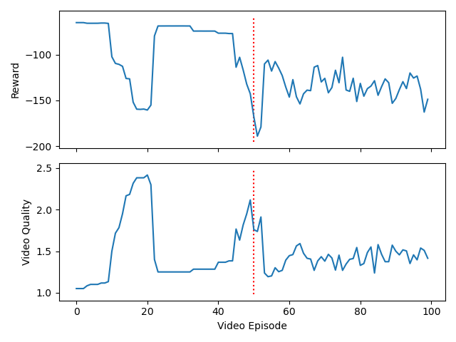

[1.46835443 1.4556962 1.29113924 1.39873418 1.44620253 1.61708861

1.66455696 1.72468354 1.51582278 1.44936709 1.60443038 1.4335443

1.56012658 1.70886076 1.66139241 1.57594937 1.63291139 1.71202532

1.71835443 1.65822785 1.66139241 1.55696203 1.54746835 1.62658228

1.68670886 1.55063291 1.68987342 1.7056962 1.59177215 1.63291139

1.63607595 1.70253165 1.60759494 1.78797468 1.54113924 1.65822785

1.73734177 1.60759494 1.53481013 1.79113924 1.63291139 1.66455696

1.70253165 1.71835443 1.70253165 1.64873418 1.6835443 1.53797468

1.59810127 1.59810127]

[-125.55666387 -112.26141798 -114.449634 -132.31065529 -129.71817141

-134.83748674 -161.23448634 -163.33766178 -131.71960639 -132.12568275

-143.44692241 -125.75194712 -160.07024539 -153.51214459 -145.23595063

-153.67769415 -163.86831712 -155.77334993 -157.94772814 -148.35813667

-143.50629143 -147.24299507 -141.10111927 -158.56823728 -161.28635784

-132.92758749 -159.63818893 -161.11939548 -163.23085315 -161.32025304

-162.8540986 -175.01607278 -145.17991788 -189.06242304 -139.62861342

-150.18809112 -159.27607302 -139.85103629 -126.664653 -178.88643891

-140.56260211 -152.67982459 -167.71468391 -178.41605147 -151.2057786

-168.01538019 -154.55820529 -135.98199088 -148.93708893 -165.97423635]

[2.01111111 2.01111111 2.01111111 1.91111111 1.30555556 1.49444444

1.68333333 1.99444444 2.03888889 2.3 2.14444444 2.45555556

2.36666667 2.33333333 2.3 2.28333333 2.03888889 2.02777778

1.98888889 1.81111111 1.75555556 1.74444444 1.41111111 1.71666667

1.93888889 2.07222222 2.08888889 2.32777778 2.34444444 2.42222222

2.42222222 2.42777778 2.31666667 2.31111111 2.31111111 2.31666667

2.42777778 2.42777778 2.43333333 2.32222222 2.32222222 2.32222222

2.31666667 2.31666667 2.31666667 2.42777778 2.16666667 2.10555556

2.20555556 1.99444444]

[ -88.34455454 -88.34455454 -88.34455454 -80.62845064 -34.75692909

-69.43407014 -72.89052401 -77.94066456 -80.39329907 -116.72058971

-89.87428036 -132.05338975 -123.84418122 -122.13795085 -116.73170082

-117.05710385 -80.38218796 -79.68196698 -85.784138 -71.37923624

-70.97487163 -70.80254451 -33.84154803 -69.14011211 -80.5405368

-90.12239058 -90.67467717 -120.45754607 -120.81836805 -129.6770074

-129.6770074 -129.30687018 -110.90117018 -111.2713074 -111.28241851

-110.89005907 -131.94828 -131.94828 -132.95564828 -111.88631623

-111.89742734 -111.89742734 -112.83124767 -112.83124767 -112.83124767

-133.8894686 -98.51856542 -89.46284426 -118.63267862 -99.19095446]

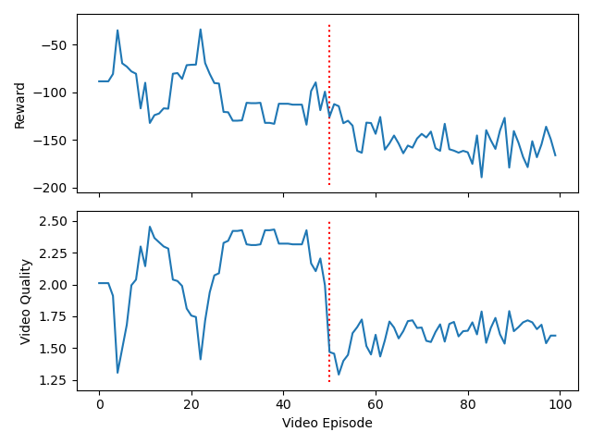

[1.45253165 1.51265823 1.54113924 1.29113924 1.21518987 1.28797468

1.2943038 1.33227848 1.22468354 1.4556962 1.30379747 1.38291139

1.30063291 1.37341772 1.42088608 1.31012658 1.34177215 1.42088608

1.44303797 1.33544304 1.28481013 1.42721519 1.61392405 1.61075949

1.54746835 1.68670886 1.51582278 1.54746835 1.51265823 1.50949367

1.48734177 1.45253165 1.58544304 1.58860759 1.49050633 1.52531646

1.44936709 1.39240506 1.38607595 1.58544304 1.50316456 1.4778481

1.5 1.53797468 1.63291139 1.65189873 1.59810127 1.59810127

1.71202532 1.71835443]

[-133.75905807 -138.66572826 -140.5856853 -117.40781174 -105.39839501

-127.68794068 -122.35399057 -132.32506062 -107.85293646 -133.68159711

-137.54307611 -148.4462253 -134.47347858 -123.9628389 -127.17553932

-116.10465882 -122.4089766 -130.42108952 -136.35148014 -123.70231703

-114.71507159 -117.94408155 -149.48292437 -147.39552122 -128.52884749

-156.2576878 -132.18770595 -131.9149679 -145.10155536 -130.75626016

-124.94911612 -136.38349113 -145.99092449 -130.42510754 -128.33745325

-147.35910089 -126.61386265 -126.53804129 -111.46402583 -151.35179631

-158.68646561 -134.69564003 -155.58501063 -123.56779496 -169.71014237

-145.89329985 -141.46378583 -143.6500369 -159.95938866 -145.52029379]

[1.72222222 1.72777778 1.73888889 1.73333333 1.73333333 1.65555556

1.31111111 1.43333333 1.31111111 1.49444444 1.55555556 1.75555556

2.39444444 2.35 1.41111111 1.42777778 1.43333333 1.45

1.47222222 1.5 1.48333333 1.46111111 1.44444444 1.44444444

1.44444444 1.51666667 1.51666667 1.51666667 1.51666667 1.51666667

1.51666667 1.51666667 1.52222222 1.52222222 1.52222222 1.52222222

1.52222222 1.51666667 1.51666667 1.53333333 1.55 1.55

1.55 1.55555556 1.55 1.57222222 1.63888889 2.12777778

2.52777778 2.55 ]

[ -70.0752687 -69.98983376 -70.78504207 -70.98089258 -70.98089258

-69.56116431 -48.91466409 -78.97731145 -68.13388639 -79.18185944

-79.20927051 -96.24100154 -135.38766774 -140.47584024 -72.19478743

-72.88737197 -72.97868314 -72.7118966 -72.648532 -77.89697313

-78.18471348 -78.22585585 -77.636043 -77.62493189 -77.62493189

-79.60651039 -79.59539928 -79.60651039 -79.57317706 -79.58428817

-79.57317706 -79.60651039 -79.74376928 -79.73265817 -79.74376928

-79.74376928 -79.7659915 -79.57317706 -79.60651039 -79.4016989

-79.22022402 -79.22022402 -79.20911291 -79.37970514 -79.45741594

-79.91996494 -81.54799992 -115.90498243 -138.5374631 -140.07659877]

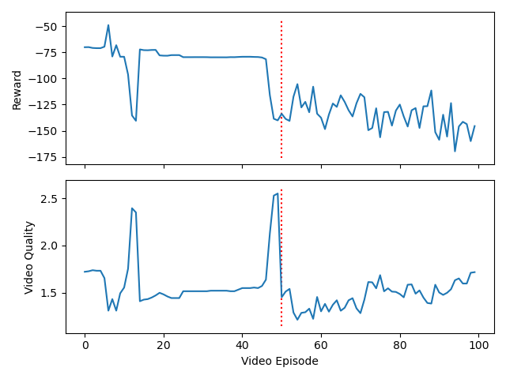

[1.42088608 1.47151899 1.44620253 1.26898734 1.23101266 1.21202532

1.2721519 1.35443038 1.36075949 1.37341772 1.2943038 1.35759494

1.35759494 1.36708861 1.55063291 1.60443038 1.55696203 1.66139241

1.53164557 1.57594937 1.63924051 1.71202532 1.59177215 1.64873418

1.53797468 1.66139241 1.51265823 1.67088608 1.6835443 1.57911392

1.65822785 1.50316456 1.64556962 1.68987342 1.59177215 1.65506329

1.51265823 1.48734177 1.47468354 1.59493671 1.60759494 1.70886076

1.44303797 1.38607595 1.60126582 1.60443038 1.64873418 1.74683544

1.60759494 1.60759494]

[-123.14714694 -141.3654404 -140.19184846 -106.29072063 -111.65384263

-101.08963029 -128.96491789 -128.56548645 -145.25958724 -128.14106353

-118.02787589 -122.24459265 -125.85127046 -159.55770762 -130.36677414

-154.52978719 -156.78561232 -158.22837827 -143.94466328 -149.63905423

-190.59439712 -155.15031648 -171.97201242 -168.19806789 -153.39047237

-172.58700449 -141.91050636 -147.39678959 -145.39474895 -136.0039254

-159.34573954 -147.17897656 -163.81917923 -154.84371893 -145.84576493

-159.57403678 -142.66882315 -124.18025474 -122.13470951 -170.32227602

-158.9117162 -160.39946765 -139.73655354 -132.1063754 -151.88707274

-146.68696005 -173.17940279 -183.36875667 -153.30648539 -146.38522668]

[1.46111111 1.47222222 1.57222222 1.71666667 2.55 2.70555556

2.71666667 2.80555556 2.85 2.85555556 2.84444444 2.8

2.79444444 2.73888889 2.73888889 2.82777778 2.82777778 2.73888889

2.82777778 2.82777778 2.73888889 2.73888889 2.82777778 2.73888889

2.73888889 2.73888889 2.73888889 2.82777778 2.73888889 2.73888889

2.73888889 2.82777778 2.82777778 2.73888889 2.73888889 2.73888889

2.73888889 2.82777778 2.73888889 2.73888889 2.73888889 2.82777778

2.73888889 2.73888889 2.82777778 2.73888889 2.73888889 2.82777778

2.82777778 2.82777778]

[ -79.22240522 -79.32859838 -79.65154218 -81.13961658 -148.63312378

-155.829031 -159.12825051 -161.84134511 -161.42295591 -164.50916153

-164.15418515 -163.52212602 -163.37767545 -158.13220909 -158.12109798

-166.39514599 -166.39514599 -158.13220909 -166.39514599 -166.39514599

-158.13220909 -158.13220909 -166.39514599 -158.13220909 -158.13220909

-158.12109798 -158.13220909 -166.39514599 -158.13220909 -158.13220909

-158.12109798 -166.39514599 -166.39514599 -158.12109798 -158.12109798

-158.13220909 -158.13220909 -166.39514599 -158.13220909 -158.13220909

-158.13220909 -166.39514599 -158.13220909 -158.13220909 -166.39514599

-158.13220909 -158.13220909 -166.39514599 -166.39514599 -166.39514599]

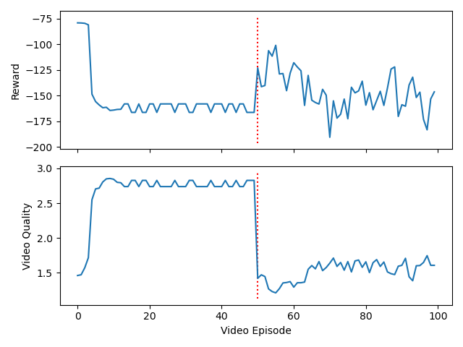

[1.36075949 1.44620253 1.48417722 1.39873418 1.41139241 1.25949367

1.35443038 1.34177215 1.41139241 1.47468354 1.42721519 1.42088608

1.48101266 1.43670886 1.39240506 1.57911392 1.57911392 1.46835443

1.50632911 1.52531646 1.46518987 1.4556962 1.5221519 1.4556962

1.57911392 1.48101266 1.47151899 1.35126582 1.44936709 1.49683544

1.52848101 1.5664557 1.5664557 1.61708861 1.5664557 1.5664557

1.55379747 1.55696203 1.42405063 1.49683544 1.66455696 1.51898734

1.60443038 1.65822785 1.5443038 1.63291139 1.61392405 1.64556962

1.69303797 1.59493671]

[-103.4325679 -111.7135951 -122.20730227 -126.66872186 -138.54643948

-115.99447856 -116.28279791 -114.39663555 -132.8028341 -117.96519768

-115.71596781 -129.21846173 -129.15988074 -152.23974231 -112.22204497

-153.92105556 -128.93645168 -130.47895088 -133.73388639 -157.0915014

-148.41031798 -140.56075093 -138.89927126 -133.56819053 -150.23694771

-131.98134413 -146.72469801 -117.23408174 -135.16678555 -122.9143152

-144.74809167 -147.79177648 -149.46334117 -156.44342948 -146.03601103

-140.14808306 -153.99834795 -140.95868901 -125.0718353 -135.95728734

-161.31761652 -140.50022545 -140.56787793 -156.95028052 -144.13430528

-154.63194331 -154.4227517 -160.6170424 -166.92806498 -179.56457586]

[1.43333333 1.5 1.82222222 1.95 2.07777778 2.07777778

2.07777778 2.07777778 2.06666667 2.02222222 1.94444444 1.51666667

1.88333333 2.34444444 2.34444444 2.35 2.35 2.34444444

2.36111111 2.36666667 2.27222222 2.28333333 2.03333333 1.58888889

1.81666667 2.17222222 2.08333333 2.14444444 2.23888889 2.26111111

2.26666667 2.25 2.15555556 2.06111111 2.02777778 2.05

2.08333333 2.03333333 2.29444444 2.44444444 2.36111111 2.4

2.45555556 2.45 2.35555556 2.23333333 2.36111111 2.37222222

2.41111111 2.21111111]

[ -76.64774744 -77.73294048 -101.91014518 -90.75125031 -90.19470681

-90.21692904 -90.19470681 -90.20581793 -89.38017479 -88.21037839

-81.80763864 -49.28114862 -100.34617919 -151.05886462 -151.04775351

-151.14840731 -151.14840731 -151.17828832 -151.28388457 -151.25400356

-145.03946039 -145.03979156 -114.4981507 -54.28405357 -77.27280906

-112.97220378 -103.71769185 -110.18638652 -118.18671851 -119.15090457

-119.10991407 -118.73705799 -110.31134173 -110.56847795 -124.12357169

-125.50545828 -129.01051885 -132.48745123 -123.98085386 -147.07729663

-141.11314732 -144.63042826 -147.11992661 -147.14271179 -143.54026373

-121.4322078 -143.51747855 -143.36195677 -145.75999898 -117.43570186]

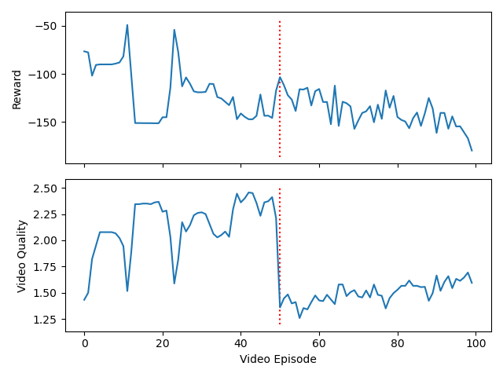

LSTM

[1.17405063 1.22468354 1.30063291 1.10759494 1.2943038 1.20253165

1.2721519 1.22151899 1.25 1.17721519 1.21202532 1.25632911

1.2721519 1.25316456 1.19936709 1.12341772 1.31962025 1.14240506

1.09493671 1.19936709 1.09177215 1.14556962 1.25 1.15189873

1.21202532 1.25316456 1.20886076 1.13924051 1.10126582 1.14240506

1.12658228 1.0664557 1.12974684 1.15506329 1.32278481 1.20253165

1.14240506 1.11392405 1.21202532 1.12341772 1.28164557 1.11075949

1.25316456 1.19303797 1.08544304 1.10126582 1.15189873 1.17088608

1.08227848 1.02531646]

[-117.44719937 -126.23486592 -105.09458583 -101.94320962 -136.3343678

-112.46605615 -133.39695554 -109.80700839 -118.70486434 -108.9015696

-118.10325286 -119.12118713 -131.31319543 -111.25090255 -93.88426395

-113.51743144 -114.51012237 -106.7660945 -102.24335426 -106.50299805

-101.52143672 -107.68976559 -115.45340098 -101.7039395 -91.49115998

-109.22939895 -118.16609224 -118.25727583 -108.98058829 -118.60007833

-92.18585982 -105.1409417 -107.29789227 -115.908523 -121.6738835

-107.15983243 -91.71038745 -113.53757997 -123.12711457 -121.71428155

-130.24898881 -111.72049518 -106.38647001 -127.1160539 -105.53590009

-93.54623436 -117.88075992 -107.14391797 -109.47406264 -96.93899161]

[0. 0. 0. 0. 0. 0.

0. 0. 0. 0. 0. 0.

0. 0. 0. 0. 0. 0.

0. 0. 0. 0. 0. 0.

0. 0. 0. 0. 0. 0.

0. 0.35 1.3 0.15555556 0. 0.

0. 0. 0. 0.25555556 0.7 0.

0.51666667 0.11666667 0.06666667 0.01666667 0. 0.

0. 0.45555556]

[ -2.22209289 -2.21098178 -2.19987066 -2.22209289 -2.22209289

-2.18875955 -2.18875955 -2.19987066 -2.21098178 -2.22209289

-2.19987066 -2.22209289 -2.22209289 -2.19987066 -2.18875955

-2.19987066 -2.19987066 -2.19987066 -2.21098178 -2.19987066

-2.19987066 -2.21098178 -2.19987066 -2.19987066 -2.18875955

-2.22209289 -2.19987066 -2.21098178 -2.21098178 -2.21098178

-2.22209289 -3.44079779 -43.50516925 -14.00025364 -2.21098178

-2.19987066 -2.18875955 -2.21098178 -2.18875955 -4.10917329

-32.2986541 -2.19987066 -16.33433673 -4.01258899 -2.02589144

-2.22879995 -2.19987066 -2.21098178 -2.18875955 -23.06995163]

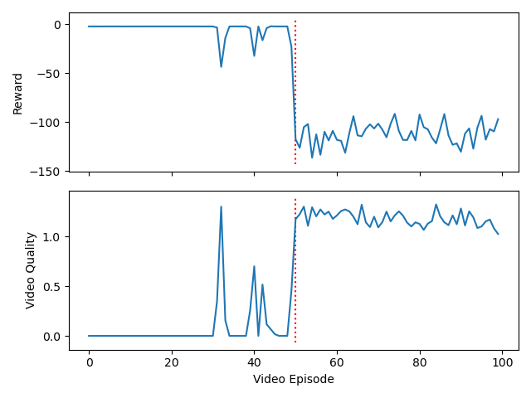

[1.78797468 1.89556962 1.95886076 1.64556962 1.65189873 1.50316456

1.23417722 1.16455696 1.12658228 1.25316456 1.30063291 1.32278481

1.29113924 1.24367089 1.23101266 1.14240506 1.14873418 1.18670886

1.1835443 1.23417722 1.19936709 1.16772152 1.12341772 1.12658228

1.30379747 1.20253165 1.15189873 1.19303797 1.11708861 1.26898734

1.19936709 1.04746835 1.16455696 1.21202532 1.09493671 1.17405063

1.21518987 1.23734177 1.21835443 1.15822785 1.33227848 1.18987342

1.2278481 1.21835443 1.19936709 1.14240506 1.16772152 1.34810127

1.12658228 1.13291139]

[-167.84167344 -190.6268497 -195.5617214 -146.10164277 -132.80045233

-140.91585754 -119.21040759 -120.17003993 -108.67665802 -130.60523872

-118.8172585 -139.22289026 -114.31868407 -129.31575274 -110.40788289

-100.84899884 -109.27031443 -104.00559736 -119.56749137 -132.89371581

-117.11293668 -101.75172161 -116.09670108 -115.85961736 -120.08994948

-114.7874663 -112.24830655 -114.40232881 -112.20309722 -123.49000112

-122.64101005 -80.23199399 -111.78506355 -110.31508568 -99.49006678

-123.19914005 -111.73610857 -123.37379386 -102.31968429 -120.7042758

-136.18645432 -111.90680815 -118.74753346 -105.42322929 -106.51502272

-121.23864594 -103.23226996 -121.04167401 -119.74590422 -102.55424684]

[0. 0. 0. 0. 0. 0.

0. 0. 0.46666667 1.22222222 1.33888889 1.28888889

1.46666667 2.02777778 1.56666667 0.26666667 0.56666667 0.08888889

0.17222222 0.86111111 1. 0.99444444 0.62222222 0.14444444

0. 0. 0. 0. 0. 0.

0.32222222 0.31111111 0. 0. 0. 0.13333333

0.38888889 0.63888889 1.33888889 0.95555556 0.62222222 0.37777778

0.11111111 0.58888889 0.07222222 0.01111111 0.01111111 0.

0.2 0.02777778]

[ -2.18875955 -2.19987066 -2.18875955 -2.22209289 -2.19987066

-2.21098178 -2.19987066 -2.19987066 -8.40908325 -31.41049165

-31.6821328 -24.92083201 -40.04519594 -76.49628652 -63.5257373

-8.68674244 -25.30376501 -2.40326986 -3.87314363 -11.82662039

-12.73964354 -12.79812639 -10.82422503 -2.9855868 -2.21098178

-2.19987066 -2.19987066 -2.22209289 -2.19987066 -2.21098178

-16.32642918 -29.0832523 -2.18875955 -2.19987066 -2.21098178

-5.81295341 -25.67180047 -9.92788299 -29.66284937 -15.75537263

-13.0153808 -7.48438639 -3.34650731 -29.80460281 -3.10951884

-2.3555721 -2.34446099 -2.22209289 -13.52898648 -5.2096202 ]

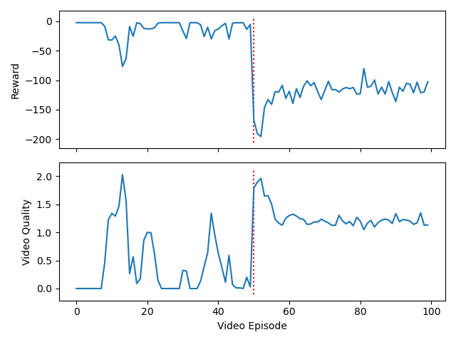

[1.49683544 1.41772152 1.37658228 1.36392405 1.42088608 1.56012658

1.63924051 1.65506329 1.56962025 1.64873418 1.58860759 1.46518987

1.37974684 1.37341772 1.55063291 1.65189873 1.51265823 1.44620253

1.43987342 1.5664557 1.64873418 1.59810127 1.43670886 1.5221519

1.50316456 1.31329114 1.44620253 1.49050633 1.50316456 1.36708861

1.40189873 1.33860759 1.31329114 1.43670886 1.54113924 1.66139241

1.54746835 1.60443038 1.48417722 1.41139241 1.34810127 1.38291139

1.46518987 1.53797468 1.65506329 1.37341772 1.46202532 1.37974684

1.38607595 1.65506329]

[-117.52524423 -117.13239956 -126.96021371 -126.78162161 -127.68123569

-118.73326607 -144.74173933 -153.71709957 -135.09434696 -133.7191562

-131.29409256 -121.94862251 -112.70273636 -105.20897942 -132.82223575

-142.39568252 -140.90105754 -123.31735677 -126.23124142 -141.60440265

-146.62058025 -146.01436743 -119.1848468 -129.1203442 -128.30613828

-101.5766701 -108.38116819 -131.88181825 -130.13174835 -122.99352792

-105.17336278 -115.89628472 -103.15596129 -127.88252666 -146.13676747

-146.39333645 -135.53088558 -140.14561491 -126.61335541 -120.68544452

-107.48213316 -116.5899658 -114.50526818 -129.40474364 -142.53885686

-119.18110135 -127.03943751 -114.71832178 -130.96869041 -144.94807822]

[1.8 1.07222222 1. 1. 1. 1.

1. 1. 1. 1. 1. 1.

1. 1.17222222 2. 2. 2. 1.47777778

1. 1. 1. 1. 1. 1.

1.06666667 1.98333333 2. 2. 1.3 1.

1. 1. 1. 1. 1. 1.

0.45555556 0.01111111 0. 0. 0. 0.

0.00555556 0.62222222 0.80555556 0.80555556 0.12777778 0.

0. 0. ]

[-58.65049775 -14.93600804 -12.72853243 -12.71742132 -12.72853243

-12.71742132 -12.73964354 -12.72853243 -12.72853243 -12.71742132

-12.73964354 -12.71742132 -12.72853243 -14.82786843 -62.62791368

-62.61680257 -62.62791368 -45.44525901 -12.71742132 -12.72853243

-12.73964354 -12.72853243 -12.72853243 -12.72853243 -14.38085298

-62.85102481 -62.62791368 -62.62791368 -35.91141798 -12.71742132

-12.71742132 -12.73964354 -12.72853243 -12.72853243 -12.73964354

-12.72853243 -7.79531142 -2.37398737 -2.21098178 -2.22209289

-2.22209289 -2.21098178 -2.21653654 -10.8634754 -6.44732919

-8.87789394 -2.85539572 -2.21098178 -2.22209289 -2.21098178]

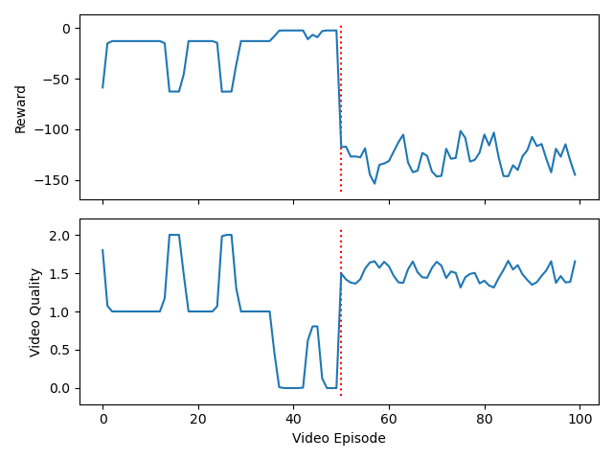

[1.8164557 1.88291139 1.80696203 1.68987342 1.12341772 1.11075949

1.17405063 1.28797468 1.21835443 1.17088608 1.09810127 1.20253165

1.13924051 1.14240506 1.11392405 1.21202532 1.25632911 1.20253165

1.09493671 1.19620253 1.23417722 1.3164557 1.15506329 1.13607595

1.13291139 1.10126582 1.19620253 1.14556962 1.11392405 1.18037975

1.1835443 1.08227848 1.25316456 1.33544304 1.09177215 1.17088608

1.23734177 1.06962025 1.19620253 1.19303797 1.25 1.17405063

1.16139241 1.15822785 1.09177215 1.19620253 1.17405063 1.11708861

1.11075949 1.20886076]

[-171.09043139 -192.17717748 -176.16035694 -153.99751599 -88.52960391

-106.22529945 -116.61040947 -122.79401608 -115.54301523 -130.76071765

-110.06685931 -114.59975064 -103.09436008 -102.19540729 -114.35924303

-124.18902878 -115.17345182 -116.79088725 -107.75298226 -134.54483253

-118.49093159 -119.24972091 -115.05498958 -103.83062153 -116.72355417

-108.3031821 -103.12373936 -94.19520908 -96.90946637 -104.59049567

-118.43748232 -118.45737663 -132.80942816 -141.6445079 -92.60112189

-104.22049344 -117.84117266 -93.73021486 -111.9106034 -118.42299419

-111.57109676 -109.79904324 -116.91839366 -120.32352624 -109.3806942

-100.18138719 -114.07346713 -110.96857442 -94.70647207 -119.4762221 ]

[0. 0. 0. 0. 0. 0.

0. 0. 0. 0. 0. 0.

0. 0. 0. 0. 0. 0.

0. 0. 0. 0. 0. 0.

0. 0. 0. 0. 0. 0.

0. 0. 0.31111111 0.95555556 0.89444444 1.07222222

0.16666667 0.04444444 0. 0. 0. 0.

0.03333333 0.23333333 0.62777778 1.07777778 0.72222222 0.

0. 0. ]

[ -2.19987066 -2.22209289 -2.19987066 -2.18875955 -2.22209289

-2.19987066 -2.18875955 -2.22209289 -2.22209289 -2.19987066

-2.18875955 -2.21098178 -2.21098178 -2.19987066 -2.18875955

-2.18875955 -2.19987066 -2.22209289 -2.19987066 -2.21098178

-2.18875955 -2.18875955 -2.22209289 -2.22209289 -2.19987066

-2.22209289 -2.21098178 -2.19987066 -2.18875955 -2.19987066

-2.18875955 -2.19987066 -5.52396685 -8.48019662 -8.15832746

-51.67256039 -8.87650777 -3.05509098 -2.18875955 -2.18875955

-2.21098178 -2.19987066 -1.88060657 -2.68484247 -6.86384894

-35.38902314 -40.12247879 -2.21098178 -2.19987066 -2.21098178]

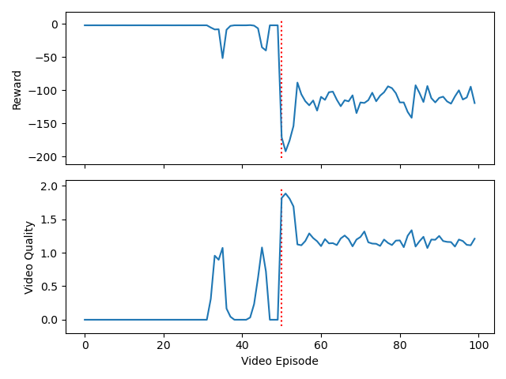

Lstm target

[1.40822785 1.38607595 1.38924051 1.51265823 1.38924051 1.42721519

1.44303797 1.46202532 1.39873418 1.47468354 1.45886076 1.37974684

1.35126582 1.33227848 1.44620253 1.33544304 1.4778481 1.43987342

1.49367089 1.48734177 1.40506329 1.33860759 1.48417722 1.43037975

1.40506329 1.50949367 1.53797468 1.38924051 1.48101266 1.46202532

1.37974684 1.40189873 1.33227848 1.42405063 1.42721519 1.34493671

1.43670886 1.31329114 1.38924051 1.45253165 1.36708861 1.33544304

1.37974684 1.37341772 1.37025316 1.50949367 1.45253165 1.2721519

1.38291139 1.34810127]

[-116.45454521 -109.98202258 -117.02958895 -134.61875849 -111.05927146

-118.13608635 -116.18936439 -122.17725977 -119.90827371 -122.92842071

-114.18423972 -117.89525772 -105.12587574 -116.69984923 -117.3896463

-113.09518277 -125.28924928 -124.72554123 -133.51843608 -124.8315197

-124.81625435 -108.81002417 -141.79055027 -126.28174959 -112.12577842

-131.94659668 -125.15923015 -127.60267217 -145.80838696 -124.80050158

-111.19504211 -128.77048057 -115.81551705 -115.10976236 -124.04337324

-122.0612758 -132.81377133 -96.07279358 -131.77095735 -138.64354389

-100.81855397 -119.33606741 -109.81586142 -98.44281685 -118.02494306

-121.52893656 -133.81993124 -105.9726095 -107.14481099 -114.06503275]

[1. 1. 1. 1. 1. 1.

1. 1. 1. 1. 1. 1.

1. 1. 0.7 0.01111111 1.2 0.5

0. 0.46666667 0.97222222 1. 0.83888889 0.05

0.33333333 1.52222222 0.02222222 0.16666667 1. 1.

1. 0.97222222 0.87777778 0.2 0.57777778 0.62222222

0.00555556 0.37777778 0.77222222 0.99444444 0.98333333 0.38333333

0.72777778 1.11111111 0.02222222 0.01666667 0.76111111 0.95

0.97777778 0.9 ]

[-12.72853243 -12.72853243 -12.72853243 -12.73964354 -12.73964354

-12.73964354 -12.72853243 -12.71742132 -12.72853243 -12.73964354

-12.73964354 -12.73964354 -12.71742132 -12.72853243 -13.95716527

-2.22221926 -40.78097609 -20.47001491 -2.22209289 -7.65079845

-13.17460361 -12.72853243 -11.67611944 -3.50549412 -6.69321686

-51.61089168 -2.99335139 -2.6351191 -12.71742132 -12.73964354

-12.72853243 -12.8293942 -12.43788707 -6.48731642 -20.59342503

-31.1785194 -2.33995673 -8.36156443 -8.84561573 -12.73822086

-12.74372601 -8.39324817 -18.91984752 -50.14688037 -5.26320498

-2.66469203 -12.00731657 -12.88448003 -12.84863267 -12.75143547]

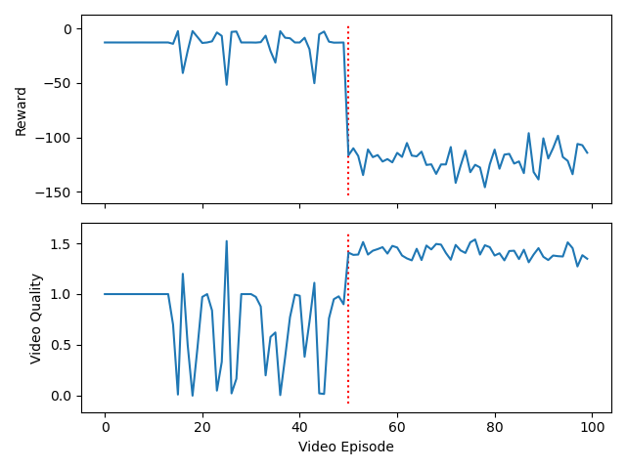

[1.52531646 1.40822785 1.46202532 1.38291139 1.51898734 1.34177215

1.5664557 1.65506329 1.58544304 1.46202532 1.38607595 1.37658228

1.61708861 1.63924051 1.35443038 1.40506329 1.39873418 1.2278481

1.43987342 1.34177215 1.5443038 1.32594937 1.21518987 1.40506329

1.46835443 1.33227848 1.47151899 1.35126582 1.42088608 1.44620253

1.28481013 1.44303797 1.27848101 1.34493671 1.46202532 1.35126582

1.38291139 1.38607595 1.40506329 1.42721519 1.42088608 1.40822785

1.37974684 1.40506329 1.38924051 1.44303797 1.40506329 1.57911392

1.44936709 1.38291139]

[-135.27467588 -114.9776646 -138.01840698 -113.64561038 -143.9088267

-111.96361893 -133.24307363 -136.61747432 -143.00598152 -120.43760028

-116.40735593 -135.79342169 -135.44728046 -142.82698275 -113.03987698

-106.43429252 -125.2097318 -107.64178365 -124.12171932 -120.252175

-133.98903231 -108.38774307 -93.75931484 -124.97761077 -129.68118707

-108.43019078 -111.9317289 -113.18413877 -121.52726146 -111.44001288

-113.57522338 -123.24910268 -106.95489666 -115.27871705 -122.73418439

-97.09134807 -133.02357467 -112.76253835 -122.60275947 -110.6563532

-120.52277443 -114.11319113 -93.97691406 -118.19277067 -113.98797443

-116.8156937 -107.69903934 -133.31339351 -108.85369912 -111.21309441]

[1. 1. 1. 1. 1. 1.86111111

2. 1.3 1. 1. 1. 1.

1. 1. 1.01111111 2. 2. 1.45

0.67777778 0.85555556 0.56666667 0.17222222 0. 0.

0.08333333 0.43333333 0.21666667 0.05 0. 0.

0. 0.04444444 0.38888889 0.25555556 0.03333333 0.

0. 0.25 0.15 0. 0.01111111 0.35555556

0.40555556 0.09444444 0. 0.02222222 0.46666667 0.

0. 0.52222222]

[-12.71742132 -12.72853243 -12.72853243 -12.73964354 -12.72853243

-50.75646489 -62.63902479 -31.41120225 -12.72853243 -12.73964354

-12.73964354 -12.72853243 -12.73964354 -12.72853243 -12.72852637

-62.63902479 -62.62791368 -40.20628249 -11.08437769 -13.00037022

-11.99970716 -7.93439344 -2.18875955 -2.22209289 -6.00921676

-33.36606124 -13.19970608 -5.71167709 -2.18875955 -2.19987066

-2.18875955 -2.25780123 -6.40800447 -6.96134315 -3.21353845

-2.18875955 -2.22209289 -12.72519736 -19.86439917 -2.21098178

-2.40951499 -9.13364074 -8.47002826 -5.51572767 -2.18875955

-2.60590323 -33.70329089 -2.18875955 -2.18875955 -4.62439425]

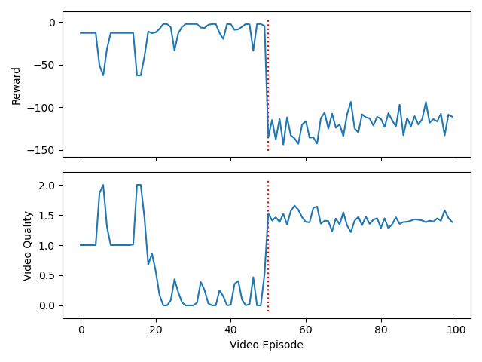

[1.56329114 1.51265823 1.58544304 1.74050633 1.53481013 1.24683544

1.24367089 1.19303797 1.22468354 1.18670886 1.16772152 1.16139241

1.18670886 1.15189873 1.21202532 1.13924051 1.12658228 1.15822785

1.22468354 1.24683544 1.08544304 1.10126582 1.21518987 1.08860759

1.16772152 1.22468354 1.19620253 1.22151899 1.22151899 1.22468354

1.15822785 1.16455696 1.11708861 1.17721519 1.25949367 1.12341772

1.19620253 1.05696203 1.11708861 1.06962025 1.2056962 1.06962025

1.12341772 1.13291139 1.15822785 1.18987342 1.00316456 1.17721519

1.11392405 1.13924051]

[-137.0088456 -131.78905251 -148.05854325 -155.04721487 -141.23982034

-114.80522916 -112.61953828 -109.97658834 -124.99595295 -111.80214534

-118.72277662 -92.31482037 -110.27133533 -106.467398 -122.70617497

-96.7346785 -105.23057167 -116.79505362 -121.03734488 -107.27614201

-130.76832843 -122.97131531 -122.84027366 -97.62296638 -117.53233655

-102.56923894 -115.52563405 -113.31103135 -117.12459633 -113.2989902

-117.05668699 -114.43623865 -116.01030467 -126.49303746 -115.21742546

-111.71640448 -119.22493312 -91.49126929 -110.16192585 -113.84056291

-118.33027315 -86.81727338 -114.23272105 -96.3070679 -113.05195278

-133.36422113 -95.10424466 -88.5749622 -97.29461565 -109.62888416]

[0. 0. 0. 0. 0. 0.

0. 0. 0. 0. 0. 0.

0. 0. 0. 0. 0. 0.

0. 0. 0. 0. 0. 0.02777778

0.57222222 1.39444444 1.55555556 0.87777778 0.26111111 0.09444444

0.00555556 0. 0. 0.06666667 0.1 0.11666667

0.16666667 0.16666667 0.36111111 0.93333333 0.79444444 0.10555556

0. 0.18333333 0.11666667 0.01666667 0. 0.

0.03888889 0.07777778]

[ -2.18875955 -2.22209289 -2.18875955 -2.18875955 -2.19987066

-2.19987066 -2.22209289 -2.21098178 -2.18875955 -2.18875955

-2.18875955 -2.19987066 -2.21098178 -2.18875955 -2.19987066

-2.21098178 -2.22209289 -2.18875955 -2.18875955 -2.18875955

-2.21098178 -2.22209289 -2.22209289 -2.18406879 -7.48766799

-30.00117438 -64.03597456 -12.78981206 -2.94943839 -2.06811209

-2.3732801 -2.19987066 -2.22209289 -2.01478033 -3.76276659

-15.12775186 -6.767102 -2.99196597 -3.94731215 -10.30811838

-11.0280236 -3.58263567 -2.22209289 -6.84036391 -4.46050672

-5.31488759 -2.22209289 -2.22209289 -2.29532578 -2.29850309]

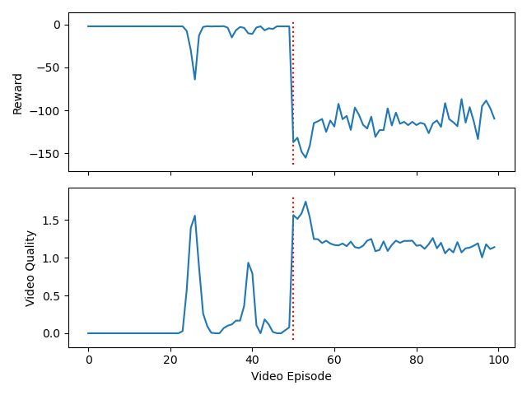

[1.17088608 1.18987342 1.16455696 1.19936709 1.16455696 1.25316456

1.24683544 1.30063291 1.11708861 1.20253165 1.12341772 1.06012658

1.35126582 1.21202532 1.14240506 1.12658228 1.21518987 1.12974684

1.25632911 1.2943038 1.32278481 1.13607595 1.28481013 1.14556962

1.09493671 1.18987342 1.25949367 1.28797468 1.12974684 1.12025316

1.25949367 1.32911392 1.13924051 1.11392405 1.17721519 1.21202532

1.24367089 1.13291139 1.2056962 1.06012658 1.17088608 1.14240506

1.12658228 1.14240506 1.14873418 1.17721519 1.26898734 1.12974684

1.2278481 1.11075949]

[-109.37328491 -99.74073064 -105.00273346 -98.65229486 -101.73098246

-121.04186589 -119.94428652 -118.78975741 -105.81677468 -122.58639066

-87.17083074 -112.8273886 -138.19610012 -131.09400718 -105.91926074

-121.14025924 -109.9888155 -95.93319445 -117.22662996 -126.82480099

-106.54243729 -118.64433364 -134.32259495 -108.45350079 -104.64035696

-105.43478113 -119.07408841 -131.57165446 -113.56057485 -102.49122423

-119.51784519 -142.05695567 -109.24676954 -104.63803106 -114.6041724

-116.36420712 -125.89288497 -104.03591298 -121.78882924 -94.02587733

-118.0697389 -108.12100065 -101.92728191 -101.11341285 -114.28540215

-103.77636337 -111.78892797 -103.70736076 -103.97499011 -123.44839265]

[0. 0. 0. 0. 0. 0.

0. 0. 0. 0. 0. 0.

0. 0. 0. 0. 0. 0.

0. 0. 0. 0. 0. 0.

0. 0. 0. 0. 0. 0.

0. 0. 0. 0.1 0.8 0.14444444

0.02222222 0.02222222 0.01111111 0.05 0.00555556 0.21111111

0.02222222 0.02777778 0.07222222 0.05555556 0.03333333 0.07222222

0.17222222 0. ]

[ -2.19987066 -2.22209289 -2.19987066 -2.19987066 -2.22209289

-2.18875955 -2.21098178 -2.22209289 -2.19987066 -2.18875955

-2.22209289 -2.18875955 -2.22209289 -2.19987066 -2.22209289

-2.18875955 -2.21098178 -2.18875955 -2.22209289 -2.22209289

-2.22209289 -2.21098178 -2.21098178 -2.19987066 -2.19987066

-2.22209289 -2.22209289 -2.18875955 -2.18875955 -2.18875955

-2.21098178 -2.21098178 -2.22209289 -2.33905444 -11.97155002

-3.19921474 -2.23062636 -2.23062636 -2.17121437 -6.16879969

-2.22756874 -16.75510073 -2.70743537 -2.18406879 -2.2608581

-2.10957063 -1.90026431 -5.36656925 -7.10106381 -2.19987066]

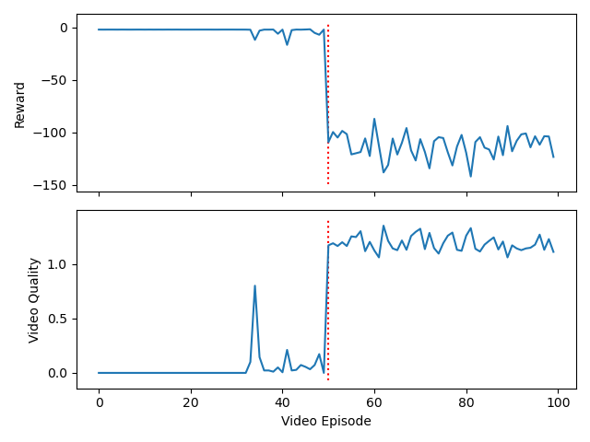

[1.43987342 1.36392405 1.50316456 1.49367089 1.33544304 1.26265823

1.26265823 1.21518987 1.15189873 1.19936709 1.16139241 1.15822785

1.18987342 1.2278481 1.15506329 1.31329114 1.20253165 1.2721519

1.05379747 1.19303797 1.28797468 1.20886076 1.20253165 1.28164557

1.12025316 1.10759494 1.13924051 1.10126582 1.16772152 1.21202532

1.19303797 1.13924051 0.99683544 1.09493671 1.12974684 1.15189873

1.10126582 1.21518987 1.12974684 1.1835443 1.15822785 1.17721519

1.18670886 1.1835443 1.13924051 1.17088608 1.14240506 1.02531646

1.15822785 1.16139241]

[-117.95455924 -112.79003663 -120.79382907 -128.81042053 -102.99524217

-123.53024048 -130.94484247 -118.8408812 -122.83840836 -115.44763128

-123.56751906 -108.19668722 -113.08049946 -125.05454969 -113.13051969

-125.39505188 -104.37246402 -134.18637392 -104.98307523 -107.04024186

-119.84236463 -104.09662406 -108.36745927 -127.76100775 -111.17768102

-126.33374503 -109.15028184 -96.69296504 -122.3753958 -112.95447797

-110.55148583 -96.65105725 -119.53808583 -100.34192989 -112.75875595

-106.68643116 -96.11351469 -122.96293421 -100.53845038 -107.30355561

-102.78973125 -110.88119349 -115.87102534 -111.3363569 -120.09883779

-114.51527655 -106.63938345 -97.8810383 -113.38609711 -102.03510128]

[0. 0. 0. 0. 0. 0.

0. 0. 0. 0. 0. 0.

0. 0. 0. 0. 0. 0.

0. 0. 0. 0. 0.27222222 0.96666667

0.98333333 0.35555556 0.11111111 0. 0. 0.11666667

0.71666667 0.82777778 0.28333333 0.07222222 0. 0.

0. 0.02777778 0.71111111 0.90555556 0.55 0.18333333

0.04444444 0. 0. 0.07777778 0.61666667 0.87777778

0.82777778 0.32222222]

[ -2.19987066 -2.19987066 -2.19987066 -2.18875955 -2.21098178

-2.22209289 -2.22209289 -2.21098178 -2.22209289 -2.21098178

-2.22209289 -2.22209289 -2.18875955 -2.19987066 -2.21098178

-2.21098178 -2.21098178 -2.19987066 -2.22209289 -2.22209289

-2.22209289 -2.18875955 -3.35926219 -9.50899436 -12.34502812

-5.38902459 -3.40171379 -2.19987066 -2.22209289 -2.16279284

-6.844497 -11.44379072 -8.35483772 -2.38924221 -2.21098178

-2.19987066 -2.19987066 -2.41147162 -8.16123656 -8.73128134

-8.25466934 -3.17142092 -2.61593576 -2.22209289 -2.19987066

-2.47160032 -6.79159434 -7.87225814 -8.529179 -5.73438232]

